Students Table

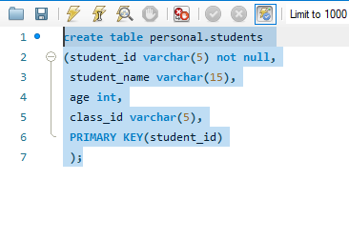

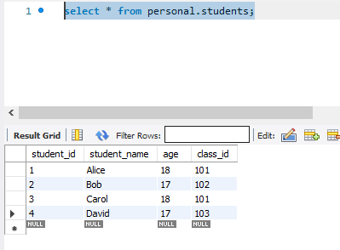

Classes table

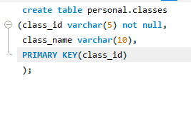

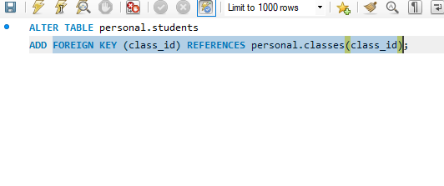

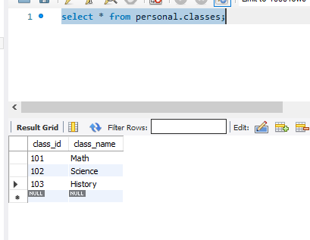

Score table

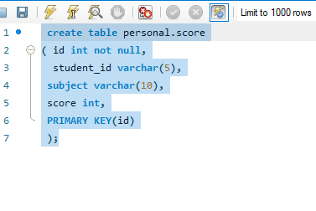

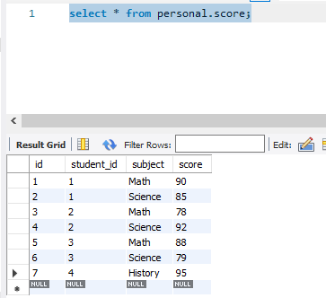

-----------------------------------------------------------------------------------------------

**Queries :**

1. Question: For each class, find the student(s) who scored the highest in Science.

select s.student_name ,sc.subject, sc.score from personal.students s

join personal.score sc on s.student_id = sc.student_id

where sc.score = (select max(sc1.score)

from personal.score sc1 where sc1.subject = "Science" group by sc1.subject);

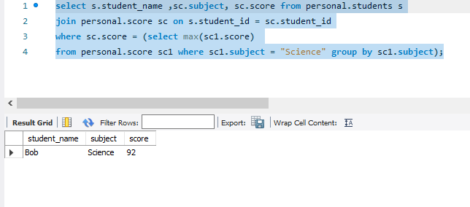

-----------------------------------------------------------------------------------------------

2. Question: List the names of students who scored lower in Math than their average Science score.

select s.student_name ,sc.subject, sc.score from personal.students s

join personal.score sc on s.student_id = sc.student_id

where sc.subject = "Math" and sc.score < (select avg(sc1.score)

from personal.score sc1 where sc1.subject = "Science" group by sc1.subject);

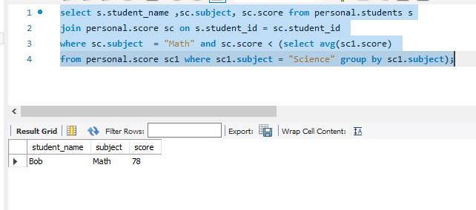

-----------------------------------------------------------------------------------------------

3. Question: Display the class names with the highest number of students who scored above 80 in any subject.

Query1 : create table personal.temp_score select sc.subject,count(*) as no_of_students_above_80

from personal.score sc where sc.score > 80 group by sc.subject ;

query2 : select subject from personal.temp_score where no_of_students_above_80 =

(select max(no_of_students_above_80) from personal.temp_score tsc);

Query 3: drop table personal.temp_score;

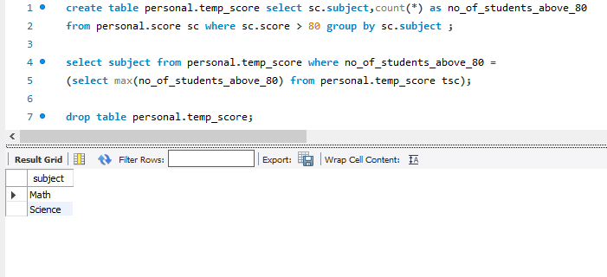

-----------------------------------------------------------------------------------------------

4. Question: Find the students who scored the highest in each subject.

SELECT m.subject,s.student_name,m.score

from personal.students s

inner join personal.score m on s.student_id=m.student_id

inner join personal.classes su on m.subject=su.class_name

inner join (select subject

,max(score) as maximum

from personal.score ma group by subject

) highmarks

ON highmarks.subject=m.subject

AND highmarks.maximum=m.score

order by subject,student_name;

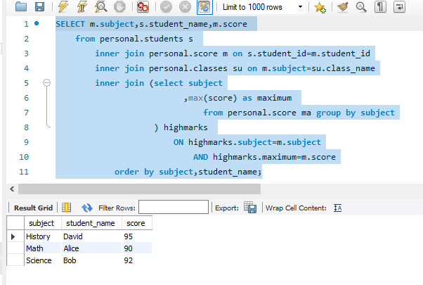

-----------------------------------------------------------------------------------------------

5. Question: List the names of students who scored higher than the average of any student's score in their own class.

select distinct s.student_name,sc.score,sc.subject from personal.students s

inner join personal.score sc on s.student_id = sc.student_id

inner join (select subject,avg(score) a from personal.score group by subject) avgScore

where sc.score > avgScore.a and sc.subject = avgScore.subject;

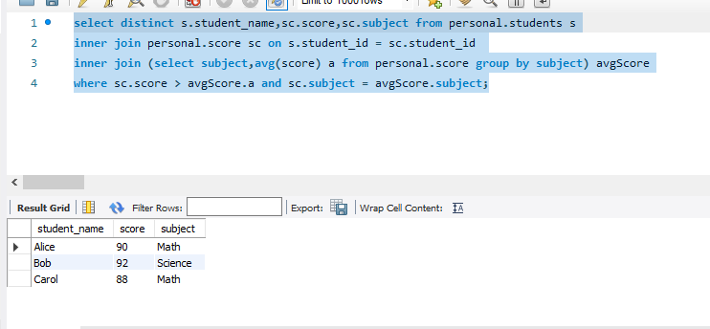

-----------------------------------------------------------------------------------------------

6. Question: Find the class(es) where the students average age is above the average age of all students.

select distinct c.class_name from personal.students s

inner join personal.classes c on s.class_id = c.class_id

where age > (select avg(age) from personal.students ) ;

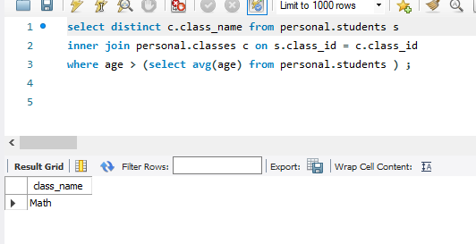

-----------------------------------------------------------------------------------------------

7. Question: Display the student names and their total scores, ordered by the total score in descending order.

select sc.student_id,s.student_name,sum(sc.score) total_score from personal.score sc

join personal.students s on sc.student_id = s.student_id

group by student_id

order by total_score desc;

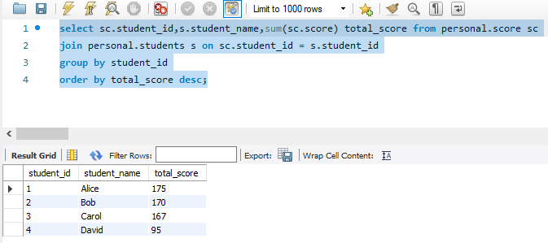

-----------------------------------------------------------------------------------------------

8. Question: Find the student(s) who scored the highest in the class with the lowest average score.

select distinct s.student_name , sc.score from personal.students s

inner join personal.score sc on sc.student_id = s.student_id

inner join (select max(score) mx from personal.score group by subject) maxScore on

inner join (select avg(score) avgs from personal.score group by subject) avgScore

where sc.score = (select max(maxScore.mx) from maxScore) and

sc.score = (select min(avgScore.avgs) from avgScore);

-----------------------------------------------------------------------------------------------

9. Question: List the names of students who scored the same as Alice in at least one subject.

select s.student_name,sc.score from personal.score sc

inner join personal.students s on sc.student_id = s.student_id

inner join (select sc.score from personal.score sc

inner join personal.students s on sc.student_id = s.student_id

where s.student_name = "Alice") al

where al.score = sc.score and s.student_name <> "Alice";

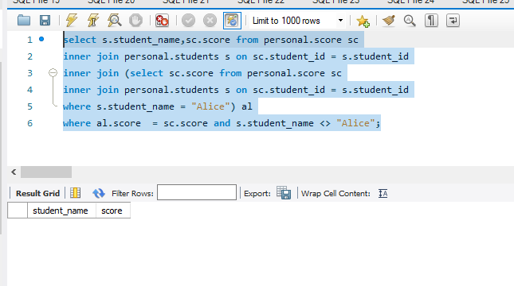

-----------------------------------------------------------------------------------------------

10. Question: Display the class names along with the number of students who scored below the average score in their class.

select distinct c.class_name , s.student_name from personal.students s

inner join personal.classes c on s.class_id = c.class_id

where age < (select avg(score) from personal.score ) ;



